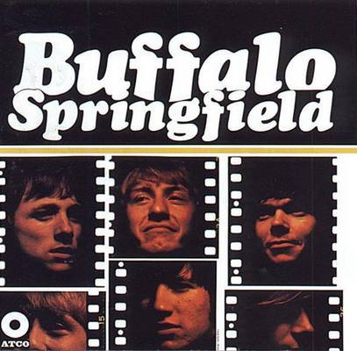

For What It's Worth (Stills)

E A9
1. There's something happening here
E A9
What it is ain't exactly clear
E A9
There's a man with a gun over there
E A9
Telling me that I've got to beware

E D
- I think it's time we stop, children, what's that sound
A
Everybody look what goin' down

2. There's battle lines being drawn
And nobody's right, if everybody's wrong
Young people speaking their minds
Getting so much resistance from behind

3. What a field day for the heat
A thousand people in the street
Singin' songs, and carryin' signs
Mostly say "hooray for our side"

4. Paranoia strikes deep
Into your life it will creep
It starts when you're always afraid
Step outta line, the men come, and take you away
Go And Say Goodbye (Stills)

G F C D
1. You ask me to read this letter that you wrote the night before
G F C D
And you really should know better 'cause she's worth a whole lot more

G C G C G C G
- Brother you know you can't run away and hide
C C/B Am Am/G D D7
Is it you don't want to see her cry is that why
G C G C G C G
You won't go and say goodbye

2. Then you said the fault was yours and you really were to blame
Was as if to close the doors and to hide away in shame

A7 D G
-- Yes and why tell me why can't you see that it's not right
A7 D
It's a lie, it's a lie, don't hide your sorrows in the night

3. And I know the pain is double, but for her it's even worse
You must face her with her trouble, though it's hurting like a curse

Sit Down I Think I Love You (Stills)

F# B C# F# B G#m C#
1. Sit down, I think I love you; anyway I'd like to try
F# B C# F# B G#m C#
I can't stop thinking of you; if you go I'll know I cry

B F#
- Can't you see that I'm a desperate man, I can hide, just being around
B
You want to know what they say about 'the bird in the hand',
C#
and that's why, I ain't leaving without you

2. So if you want someone to love you, pretty baby, I'm your guy
It's not much I'm asking of you, just a 'please give me a try'

Nowadays Clancy Can't Even Sing (Young)

Dmj7 Gmj7
1. Who's that stomping all over my face,
Djm7 Gmj7
where's that silhouette I'm trying to trace?
Dmj7 Gmj7
Who's putting sponge in the bells I once rung
Dmj7 Gmj7
And taking my gypsy before she's begun
Bm Em
To singing the meaning of what's in my mind
Bm Em
before I can take home what's rightfully mine.
Bm Em
Joinin' and listenin' and talkin' in rhymes
Bm Em
stoppin' the feeling to wait for the times.
G A
Who's saying baby, that don't mean a thing
Bm D Em G F#m Bm
Cause nowadays Clancy can't even sing.

2 And who's all hung-up on that happiness thing
Who's trying to tune all the bells that he rings
And who's in the corner and down on the floor
With pencil and paper just counting the score?
And who's trying to act like he just in between,
The night isn't black, it can only be screened.
Don't bother looking, you're too blind to see
Who's coming on like he wanted to be.
Who's saying baby, that don't mean a thing...

3. And who's coming home on the old ninety five,
Who's got the feeling to keep him alive,
Though havin' it, sharin' it ain't quite the same
It ain't no gold nugget, you can't lay a claim
Who's seeing eyes through the crack in the floor
There it is baby, don't you worry no more
Who should be sleepin' but is writing this song
Wishin' and a-hopin' he weren't so damned wrong
Who's saying baby, that don't mean a thing...

Hot Dusty Roads (Stills)

A G D F#°
1. I don't tell no tales about no hot dusty roads
A E7
I'm a city boy and I stay at home
A G D F#°
I make no excuses I just don't want to roam
A D7 A E7
And I don't like being alone
2. I give you loving and a place to take off your shoes
It does surprising things for a case of the blues
It ain’t no club, you don’t have to pay no dues
You just love me and I love you
D
- And if you take some pride in being alive
A A7
If you're interested in looking inside - of yourself
D
Just drop on by, baby ask me why
G E D7
At least you don't have to be by - yourself
3. Just come knock, most likely I'll be there
Then you look around, find a comfortable chair
And then you sit, and you might think about
Why he's there, I can't tell you why, only where

Everybody's Wrong (Stills)

G C Cm
1. Listen to my song, it isn't very long
G F Dm G
You'll see before I'm gone that everybody's wrong
2. Those of us who run to catch a moment in the sun
Seem to find the when we're done that we weren't supposed to run

C7 G
- And there's too many words going down
C7 G
They keep wrecking against the walls with the hollow sounds
C Cm
All about what it's going to be, yes, you know what it was you see
Bb D
It ain't plenty, you and me not a crown
3. Finding what you sought after all the time you fought
Sometimes leave's you with the thought that perhaps you just been caught
Flying On The Ground Is Wrong (Young)

A A6 Amj7 A6 Am

A A6 Amj7 A6 A A6 Amj7 A6
1. Is my world not falling down, I’m in pieces on the ground
Bm A A6 Amj7 A6
And my eyes aren’t open and I’m standing on my knees

E Bm D Bm
But if crying and holding on and flying on the ground is wrong
A A+ D Bm
Then I’m sorry to let you down but you’re from my side of town
A A6 Amj7 A6 Am
And I’ll miss you

2. Turn me up or turn me down, turn me off or turn me ‘round
I wish I could have met you in a place where we both belong
But if crying...

F G Em Am
- Sometimes I feel like I’m just a helpless child
F G C E
Sometimes I feel like a king, but baby
Amj7 Bm Amj7 Bm Amj7 D
Since I have changed I can’t take nothing home

3. City lights at a country fair never shine but always glare
If I’m bright enough to see you you’re just too dark to care
But if crying...

Burned (Young)

C F C F
1. Been burned and with both feet on the ground,
C F G
I've learned that it's painful comin' down.
C Em Dm F
No use runnin' away, and there's no time left to stay;
C Em Am
Now I'm finding out that it's so confusin',
C Em Fmaj7
No time left and I know I'm losin'.

2. Flashed and I think I'm fallin' down,
(Flashed and I think I'm falling down.)
Crashed, and my ears can't hear a sound
No use runnin' away...

Do I Have To Come Right Out And Say It (Young)

(G) C
1. Do I have to come right out and say it
G C
Tell you that you look so fine
G C C/B Am Am/G D/F#
Do I have to come right out and ask you to be mine
2. If it was a game I could play it
Trying to make it but I'm losing time
I got to bring you in, you're overworking my mind
Gmj7 Fmj7 Am G
- Indecision is crowding me, I have no room to spare
Fmj7 Em
And I can't believe she cared
Gmj7 Fmj7 Am G
Like a dream she has taken me and now I don't know where
Fmj7 Em Fmj7 Em G
And a part of me is scared, the part of me I shared once before

Leave (Stills)
E7
1. Nobody knows, nobody sees that what you can do we know it please
A7 E7 F#m7 F E7
But in most of the time not me, yeah hear my please, please
2. Go away, to stay, get out of my life, you've been my wife
I've been a Jew to be, yeah hear my please, please

A E
-You will be sorry when you wake up tomorrow and you leave a lover won't leave a love
A B
You won't accept the fact that I'm not ready for the days above forever, love
3. By the look on your face is that you're make it to another place
I see you around, my sweet, won't you please hear my please, please

Out Of My Mind (Young)
A E D E
1. Out of my mind, and I just can't take it anymore
A E D E
Left behind, by myself and what I'm living for
D Bm A F#m D Esus E
All I hear are screams, from outside the limousine that are taking me

2. Out of my mind, through the keyhole in an open door
Happy to find, that I don't know what I'm smiling for
Tired of hanging on, if you miss me I've just gone that are taking me
Baby Don't Scold Me (Stills)

E7
1. Baby, don't scold me, you know I'm not old enough to recognize
A7 E7
All the signs of you might buyin', if you just told me, from now on it
G A G B
Put me wise to spill it when you, baby, you, you've got eyes

2. That you just like me, you dream of one like me
But when it comes to the words they sound absurd taken like me, from now on it
Put me wise to spill it when you, baby, you, you've got eyes

C#m B C#m E
- When you see the sun you don't have to run
C#m B C#m Cmaj7 Bm7 A
Stand and watch it, not an extra mo - ment will it last if you

3. Need me you don't have to leave me, baby just
Let me feel something real and if you'll leave me from now on it
Put me wise to spill it when you, baby, you, you've got eyes

Pay The Price (Stills)

E7
1. Well I heard the story once before and I know what the tears are for
That's a lie and I just can buy you came for me so don't try

A D E
- And I see another man in your eyes
A D E
Yes, and you're old enough to know you can live twice
C#m
Yes, and so I'm telling you just exactly what to do
A D E
'Cause you can have from me some advice, pay the price
2. And if on another time or place, another day, another face
I'm telling you babe it's all you know that one of us should have to go
3. Yes and I know you hate to see me cry but I have to go and I tell you why
Without your love I can't go on, it's easy and it's wrong

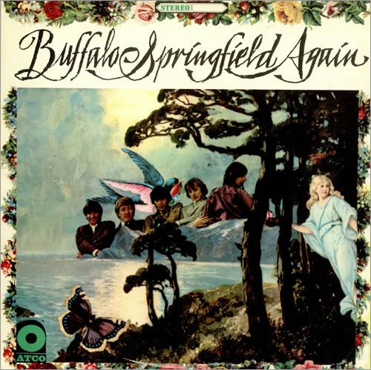

Mr. Soul (Young)

E7
1. Oh, hello Mr. Soul I dropped by to pick up a reason
for the thought that I caught in my head is the event of the season
A E7
Why in crowds just the trace of my face could seem so pleasin'
D A E7
I'll cop out to the change, but a stranger is putting the tease on

2. I was down on a frown when a messenger brought me a letter
I was raised by the praise of a fan who said I upset her
Any girl in the world could have easily known me better
She said "You're strange, but don't change;" and I let her

3. In a while will the smile on my face turn to plaster
Stick around while the clown who is sick does the trick of disaster
For the race of my head and my face is moving much faster
Is it strange I should change I don't know why don't you ask her

A Child's Claim To Fame (Furay)

G C G C G D
1. Well there goes another day and I wonder why
C G C G
You and I keep telling lies
2. I can't believe that what you say 'cause tomorrows lullaby
Can't passify my lonesome crying
3. Make believe is all you know and to make believe is a game
A child's rein you've changed your name
4. So sadly I watched the show and you see what you became
Truth is the shame, too much pain

Everydays (Stills)

Cm F Cm F
1. Look at the sad goodbyes, everyday's a killin' time
Cm F Cm F
Sun comin' up outside, no men are born this time
Cm F Cm F
Saturday's child stays home, nothin' you say is so wrong
Cm
- Well, well, well, another day
Well, well, well, another day
2. Grocery store, Templex just makin' change, plastic checks
Up in a tree a jailbird yellin' at me, no words
Every one looks, can't see can be ignored easy
- Well, well, well, another day...

Eb F7
-- Softenin' the wayward things of ecstasy
Eb Dm Cm
The sound of trees, most any please what a ba - by sees
3. Beautiful face, alright, many a place uptight
Old woman there in red shoes, a million balloons, all hues
Drive in the hills, forget fear, gettin' it on in second gear

Expecting To Fly (Young)

C Gm F G
1. There you stood on the edge of your feather, expecting to fly
C Gm F G C
While I laughed, I wondered whether I could wave goodbye
F Bb
Knowin' that you'd gone
Cm F Bb Ebmj7
By the summer it was healing we had said goodbye
Cm F Bb Ebmj7
All the years we'd spent with feeling ended with a cry, babe
Bbmj7 Ebmj7 Bbmj7 C
Ended with a cry, babe, ended with a cry

2. I tried so hard to stand as I stumbled and fell to the ground
So hard to laugh as I fumbled and reached for the love I found
Knowin' it was gone
If I never lived without you now you know I'd die
If I never said I loved you now you know I'd try, babe
Now you know I'd try, babe, now you know I'd try, babe

Bluebird (Stills)

G G/B D G G/B D
1. Listen to my bluebird laugh, she can't tell you why
G G/B D C G/B G/A D C G/B D C G/B D
Deep within her heart you see, she knows only cryin', just cryin', yeah

2. There she sits, a lofty perch, strangest color blue
Flying is forgotten now, she thinks only of you, just you, awww

D7
- So get all those blues, must be a thousand hues
C G/B
And each is differently used, you just know
D7
You sit there mesmorized by the depth of her eyes
C G/B
If you could catagorize, she got soul
C G/B C G/B D
She got soul, she got soul, she got soul

3. Soon she's going to fly away, sadness is her own
Fill herself a bath of tears and go home, and go home

Hung Upside Down (Stills)

Bm A E
1. Look what's happening to me, I'm going blind, please help.
Bm A E D C#m A
There I sat until three, gettin' further behind myself, behind my myself.

E Bm A E Bm A E
- And I'm hung upside down, and I'm hung upside down
E Bm A E Bm A E
And I'm hung upside down, and I'm hung upside down
Bm A E
Hung upside down.

F# C#m A B Solo: B7 A E, A E, A E

2. Someday I will be free, and there'll be times, you just wait.
I will come to you, see, what I'll bring you when I get straight, oh it's too late.

Sad Memory (Furay)

Cm7 Bbmj7 Cm7 F Bbmj7
1. Soft winds blow in the summer time, young lovers feel so free
Cm7 Bbmj7
Walking hand in hand down a shady lane,
Ebmj7 F Bbmj7 Ebmj7 F Bbmj7
What happened to me, what happened to me

2. Did you ever love a girl who walked right out on you
You should know just how I feel then, why I'm so blue, why I'm so blue

3. How can I forget those nights when she kissed me soft and true
whisper the words only lovers know, I love you, I love you

4. Well I've made up mine I'll find a new girl who'll love me tenderly
Forget the past I've left behind, to sad memory, to sad memory

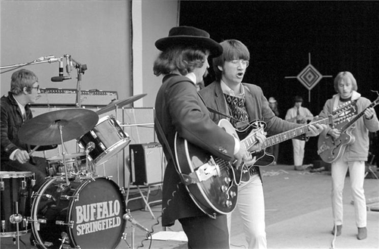
Good Time Boy (Furay)

E7 A7 E7 A7
1. Now look what I've done, it seems that I own some
E7 A7 D A B
As all it turn back now to see, yeah
E7 A7 E7 A7
Me in all of the good times and all of my bad lines
E7 A7 D A B
Upstaging a climaxing dream, yeah
E G
- Cause it's all right to be your good time boy
A D E
If it's all right be your good boy
If it's all right to be your good time, boy
If it's all right it's all right, yeah

2. Why should I mind if I step right out of line
And I get caught by her, get caught by her, lucky me, yeah
'Cause now I've loved a few, that's why they call me, call me "good old dude"
And I can't, I can't change right now, it seems, yeah

Rock & Roll Woman (Stills)

D7/9 G/D D7/9

F D7
1. There's a woman that you ought to know
F D7
And she's coming singing soft and low
D
Singing rock n roll, she's a joy to know

2. Neath the shadow of her soothing hand
I am free there just to make my plans
Dream of far away lands, anything close at hand

Am D
- And she will follow me why, do you know
Am D
Familiar places she's been by, that I know
Am D C D D7
Could it be she don't have to try

F D F D F D F D

3. And tomorrow she's a friend of mine
And the sorrow I see her face is lined
She's no longer mine, she's just hard to find
Broken Arrow (Young)

G Bm Em C
1. The lights turned on and the curtain fell down,
Am D
And when it was over it felt like a dream,
Am D
They stood at the stage door and begged for a scream,
G G/F# Em
The agents had paid for the black limousine
C D
That waited outside in the rain.
G Gsus G C C9 C
Did you see them, did you see them?

F Fmaj7 F6, F Fmaj7 F6

Dm G7 Bb Dm Em F Em
- Did you see them in the river, they were there to wave to you.
Dm G7 Bb Dm Em
Could you tell that the empty quivered, brown skinned Indian on the banks
F Em F G
That were crowded and narrow, held a broken arrow

2. Eighteen years of American dream,
He saw that his brother had sworn on the wall.
He hung up his eyelids and ran down the hall,
His mother had told him a trip was a fall,
And don't mention babies at all.
Did you see him, did you see him?

- Did you see him in the river, he was there to wave to you.
Could you tell that the empty quivered,
Brown skinned Indian on the banks
That were crowded and narrow, held a broken arrow?

3. The streets were lined for the wedding parade,
The Queen wore the white gloves, the county of song,
The black covered caisson her horses had drawn
Protected her King from the sun rays of dawn.
They married for peace and were gone.
Did you see them, did you see them?

- Did you see them in the river....

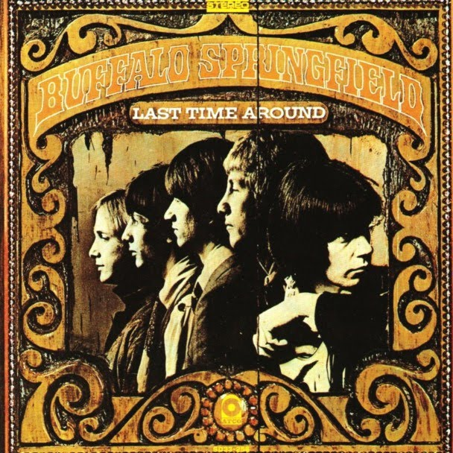

On The Way Home (Young)

F C F C F C F C
Ooo ooo ooo, Ooo ooo ooo

C Fmj7 C
1. When the dream came, I held my breath with my eyes closed
Fmj7 C
I went insane, like a smoke ring day when the wind blows
F C F Dm G
Now I won't be back till later on if I do come back at all
Bb F Gm7
But you know me (you know me) and I miss you now

2. In a strange game, I saw myself as you knew me
When the change came, and you had a chance to see through me
Though the other side is just the same you can tell my dream is real
Because I love you, can you see me now

Gm7 - F C F C

F C F Dm G
Though we rush ahead to save our time we are only what we feel
Bb F Gm7 F C F C
And I love you (I love you) can you feel it now, yeah
It's So Hard To Wait (Furay/Young)

E Bm7 D A F#
1. I just can't seem to get movin', love me enough to begin
Cmaj7 E
And I'll never forget you

Cmaj7 A Cm7 Bm7 E
- I hope that you care more than a little for me
Cmaj7 A
It's so hard to wait

Cmaj7 A Cm7 Bm7 E
- If I should stand and stare don't be alarmed at me
Cmaj7 A
It's so hard to wait

2. I just can't seem to get movin', love me enough to begin and I'll never forget you

Four Days Gone (Stills)

C Bb F Am

C Bb F Am
1. I met two kind people on the road
C Bb F Am
I was parched and dry from the cold

Bb Am
- I’ve been travelling for four days and nights, sir
Bb Am
And I do want to thank you for the ride, sir
Bb Am
And the soup your wife made tasted fine
Dm G7
If it’s all the same I’ll be on my way at the next turn
C Bb F Am
I’m three miles short from my town

- And my baby is waiting I hope, sir
After fifteen trucks and and old Ford
And the government madness I run away
And I hate to say I can’t tell you my name
Cause I’m four days gone into running

Bb C Bb C
-- I can’t even go home, take my baby and run
Bb C Bb C
I’ve got a reason to live, I’ve got the things I can give
C Bb F Am
And I’m four days gone into running

Carefree Country Day (Messina)

C A7 Dm7 G
1. I get up in the morning with a cock-a-doodle-do,
C A7 Dm7 G
I get myself together if and when I choose.
F Em Dm G F G
I'm just buckin' time, without a reason or rhyme,
Ab Gm Fm C A7 D7 G C A7
Oh what a wonderful way to spend a carefree country day
D7 G C F
I got to have it that way.
2. I best get all my chores done, got some friends a comin' by.
There's part of country livin', just trying to get by,
I'm just buckin' time...
3. I make myself a livin' off a haulin' on junk,
A man can live on thrivin' from searchin' the dump.
I'm just buckin' time...

Pretty Girl Why (Stills)

Emaj7 Cmaj7 Emaj7 Bm7

Emj7 Cmaj7 Emaj7 Bm7
1. Like the ghost of someone near she comes to haunt me in my sleep
Emaj7 Cmaj7 Emaj7 Bm7
Still I'm able to sincerely get her heart away from his

E Bm7 E Bm7
- Pretty Girl why, pretty girl why not love me?
E Bm7 E D D/C# D/B D/A Emaj7 Bm7
Pretty girl why, pretty girl why?

2. There she leaves me twice as lonely as I was but yesterday
Keeping such a hold upon my thoughts so near yet far away

- Pretty Girl why...

3. The minstrel boy has gone to war now burdened with his father's sword
Still she doesn't see how she can give him piece of lips to hold

Special Care (Stills)

D C G
1. You there in the window,
D C G
Lookin' at me, do you think I'm,
D C G
Blowing' my cool, playin' the fool?
2. You there on the corner,
Starin' at me, do you think I'm,
Trouble? Would you like to shoot me down?
And it's time for all that
3.Special Care to be taken,
To make you aware of the forsaken,
If you don't care then we'll come and burn your house down.

The Hour of Not Quite Rain (Callen, Furay)

Bm E Bm E

Bm A Bm
1. In the hour of not quite rain
G D
When the fog was finger tip high
Bm E Bm E Bm E D E Bm
The moon hung suspended in a singular sky

Bm E Bm E Bm G C F /E /D

F#m Bm F#m Bm
- Deeply and beyond seeing, not wishing to intrude
E F#m Bm
Bathed in its own reflection
A Bm E Bm E
The water mirrored the moon

2. The tumbling birds have now sobered
From the leaves of their nursery
Like shadowy, quiet children watching sleeply

Questions (Stills)

G D Am C G

D Am C G
1. Oh, what's goin' on, what are you feelin'?
D Am C G
Now that I've caught my love, my head is reelin',

D7
- With the questions of a thousand dreams,
What you do and what you see.
Come on lover, talk to me.

2. When I was on my own, chasin' you down
What was it made you run, tryin' to get around?

- With the questions of a thousand dreams...

3. Now that we've found each other, where do we go now?
I'd like to know what you're thinkin', answer me slowly now

I Am A Child (Young)

Dmaj7 Em D G D

Dm C Am F
1. I am a child, I'll last a while.
Dm F C Em
You can't conceive of the pleasure in my smile.
Dm C Am F
You hold my hand, rough up my hair,
Dm D
It's lots of fun to have you there.

Dmaj7 Em D
- I gave to you, now, you give to me,
G D
I'd like to know what you learned.
Dmaj7 Em D
The sky is blue and so is the sea.
Am C
What is the color, when black is brown?
Am D
What is the color?

2. You are a man, you understand.
You pick me up and you lay me down again.
You make the rules, you say what's fair,
It's lots of fun to have you there.
Merry-Go-Round (Furay)

G Am C G
1. Upside down on a merry-go-round, now just look at me
Am C G
Spreading your eyes to see you standing for me, it's a lover you see
Bm Em D
Not just to anyone and not just to be
Bm Em D
Someone you can call maple leave

G Am C D G Am C D
- What in the world did you do to make me love just you?
F C G F C Bb Gm
What did you do to me, what you did to me
2. This time next time which ever let be, there's something I can't deny
I'm telling you now your love is something to me, it's like a sweet lullaby
A melody that could only imply
Loving you seems to me worth a try
- What in the world did you do...

Uno Mundo (Stills)

D C G
1. Uno mundo, somebody's dreaming
D C G
Uno mundo, plansible scheming
D C G
Uno mundo, isn't he reading
D C G
Uno mundo, just the same
2. Uno mundo, Asia is screaming
Uno mundo, Africa's seething
Uno mundo, America bleeding
Uno mundo, just the same
3. Uno mundo, no me enganes
Uno mundo, somos equales
Uno mundo, porque lo ames
Uno mundo, just the same, opa!
4. Uno mundo, am I speaking?
Uno mundo, how I'm keeping
Uno mundo, additional sleeping
Uno mundo, just the same

Kind Woman (Furay)

A D A E D A D A
1. I got a good reason for loving you, it's an old fashioned sign
A D A E D A D D/C# D/B A
I kinda get the feelin' like mmm you know when I fell in love the first time.

F#m A D A A G#m F#m E
- Kind woman won't you love me tonight, the look in your eyes
F#m A D A D D/C# D/B A
Kind woman, don't leave me lonely tonight, please say it's all right

2. Remember once before hearing the old folks say love's an ageless old rhyme
Nowadays you know the sayin' depends so much on the kind of woman that you find

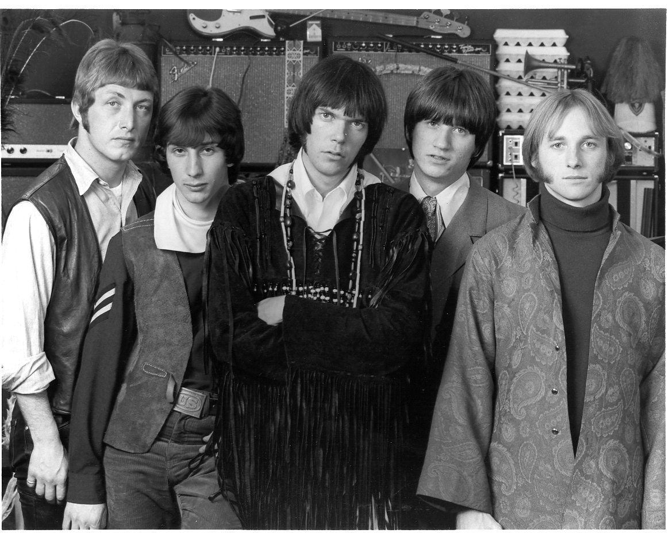

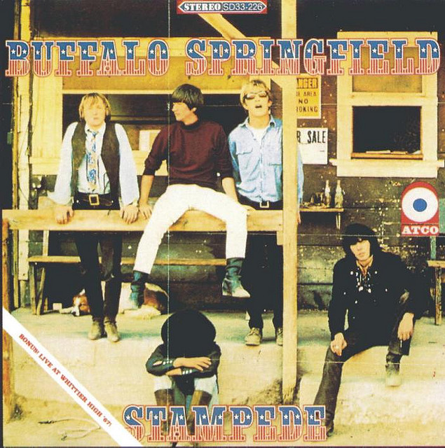

There Goes My Babe (Young)

E A B A E A B A
1. The end has come, the sky has lost it's sun
E A B A E A B A
The harm is done, he was the only one

E A E A
- There goes my babe, there goes what might have been
E G#m A E
There goes my babe in the cool morning rain
A B F#m D E A B
And now my heart lies empty and still again

2. If he were here I'd long to hold him near
But now it's clear, the price of love is dear
- There goes my babe...

Neighbor Don't You Worry (Stills)

G D A G D A
1. Neighbor don't you worry 'bout what goes on with me
Honestly what's your hurry, what is it that you want to see?

2. Here you come a-poundin' makin' the splinters fly
You act as if you're soundin' me, then you won't tell me why

B E B
- Because my friend you will find whatever you want to find
F# E B A
You think what's bad, you'll be glad, don't be blind - it's not mine

3. Is your life so boring you must impose yourself on me
If you want to go exploring, I'll just take you and you'll see

Down To The Wire (Young)

G C
1. Every time you touch her sets your hands on fire,
G C
and everything you've got is all that she requires.
B D
And you hang on, hang on, hang on to the words of a lier.
C D G C
You can feel it getting down to the wire.

2. All the hurt you thought was gone has now returned,
and everything she's laughing at is all you learned.
And you let go, let go, let go, 'cause you know you're getting tired
Can you feel it getting down to the wire?

3. Take the time to close your eyes and look around,
'cause anyone who helped you out can let you down.
And look out, look out, look out; the voice is now the choir.
Can you feel it getting down to the wire?

Come On Lover (Stills)

D7 A D7 A D A G G/F# E
1. Come on, lover, can't see that the time is late?
Let's run, cover, I want you and I just can't wait

C# F# B E
- Please decide, don't try to hide
C# F# B C
Love me, you can make the time
C# F# B E
Don't pretend everybody's your friend
C# F# B E
Just pick one and exploit them eyes

2. And don't try to figure out why, it's just a night as to kill the streets
Stolen to the pickup, fallin' in love with you like it's supposed to do

We'll See (Stills)

E G A E Esus
1. Call on by, you know I'd really like to talk to you
By and by, we might just happen to find out we two
D A
Have got more than a little in common, I
D A E
Thought just to sit a while and we'll see

2. Then we might discover differences that make us same
It's not right at all with any game you want to play
Baby, you're caught in the middle of a terrible
Role, let's sit a while and we'll see

A E A E D
- Queen of hearts, go ahead, play your parts instead of the real thing
A B
Which will never come- use your head

3. Baby please, I just don't get the point, because you see
I don't need anymore from you, than you'd expect from me
You just love with a drop of all honesty
Rise above - sayin' sit a while and we'll see

4. Ask me why the next time when I can recall your name
You still cry and yet my answer will remain the same
You just love with a drop of all honesty
Rise above- sayin' sit a while and we'll see

Nobody's Fool (Furay)

G C G D
1. Baby, you can see that it's a lie what he said to you
G C G D G
Made you sad, kind of made me glad 'cause I got the same from you

2. I ain't your fool, you'd better go away, don't apologize
No words you'd say wouldn't be okay, I'm through listenin' to your lies

C7 Fmaj7 Cmaj7
- You thought I'd be here if you came back, you were so damn sure of yourself
C7 D
But just look around, you see it ain't so, you'd better start lookin' for help

3. So many times you stood and laughed at me, now I'll take my turn
You've had your way up until today, I guess that it's time you learned

Old Laughing Lady (Young)

D Em/D Dmaj7 Em/D
1. Don't call pretty Peggy, she can't hear you no more.
D Em/D Dmaj7
Don't leave no message 'round her back door.
G/D D Em/D
They say the "Old Laughing Lady" been here before.
Dmaj7 Dm7 G D
She don't keep time, she don't count score.

D Gm7 Am7 D

2. You can't have a cupboard if there ain't no wall.
You got to move, There's no time left to stall.
They say the "Old Laughing Lady" dropped by to call.
When she leaves, she leaves nothing at all.

3. See the drunkyard of the village falling on the street.
Can't tell his ankles from the rest of his feet.
He loves his old laughing lady 'cause her taste is so sweet.
But the laughing lady's lovin', ain't the kind he can keep.

4. There's a fever on the freeway, blacks out the night.
There's a slipping on the stairway, just don't feel right.
And there's a rumbling in the bedroom and a flashing of light.
There's the "Old Laughing Lady", ev'rything is all right.

The Rent Is Always Due (Young)

C#m B G#m E
1. Your silver child suspended in space
C#m B G#m
Crying out to you
C#m B G#m E
Beckons you to yet another fine place
C#m C#
Where the trials of life are few
C# F# C# F#
- Don't think you're living long, who says you are coming on
C# G# C# F# Fm G#sus G#
They won't remember you, the rent is always due
2. The cloudy men who take their place
And stand in line they do
Know not of the satin face
That separates them from you
- Just put your blue jeans on, grab your guitar and sing a song
Don't think I'm kidding you, the rent is always due
3. She rides a broom with gold-plated straw
She flutters around and she cries
The Brylcream fools just standing on
Digesting all their lives
- But then you walk along and she starts coming on
Beneath her melting broom, the rent is always due

My Angel (Stills)

Gm7 C7 Gm7 C7
1. My angel, there she goes, where she comes from nobody knows
Gm7 F Gm7 C7
She come walkin' softly with a good word
Gm7 C7 Gm7 C7
And a smile that just glows, the kind that comes upon your nose
Gm7 F Gm7 C7
It said love me easy, I have suffered

Cm F Dm Gm Cm F Dm Gm
- It was me, somehow I knew, suddenly likewise of blue
Cm F Dm G Bb C7
She caught me in the midst of the fall and she leaned me against the wall

2. My angel, there she goes, perhaps she will, I don't know
If she does I'll be sorry but I did know
Round And Round And Round (Young)

F
- Round and round and round we spin to weave a wall to hem us in,
Gm C
It won't be long, it won't be long.
How slow and slow and slow it goes to mend the tear that always shows.
It won't be long, it won't be long.

F Gm
1. It's hard enough losin' the paper illusion you've hidden inside,
F Gm
Without the confusion of findin' you're usin' the crutch of a lie
Bbm C
To shelter your eye when you cry.

- Round and round and round we spin...

2. Now you're movin' too slow and wherever you go there's another beside.
It's so hard to say no to yourself and it shows that you're losing inside,
When you step on your pride and you cry.

Round and round and round we spin...

How the hours will bend through the time that you spend till you turn to your eyes,
And you see your best friend looking over the end and you turn to see why,
And he looks in your eyes and he cries.

Down Down Down (Young)

Dm Em/D F/D Em/D, Dm Em/D F/D Em/D

Dm G/D Bb Dm
- Come to see her in the river, she'll be there to wave to you
Dm G/D Bb Dm Em/D F/D Em/D F G
In the hope that you'll forgive her she will join you there

Dm Em/D F/D Em/D F G
1. Find out that now was the answer to answers, that you gave later
Dm Em/D F/D Em/D F G
She did the things that we both did before now, but who forgave her

- Now you see how down you've fallen, now you hear you're conscience call
Find yourself forlorn forstallen, I'm not there to call

2. Call me a fool cause I need her and see her but now you're down
Something inside you, will tell you I'm wise to what you're spreading round

- If I could stand to see her crying I would tell her not to care
When she hears of all you're lying she will join you there
My Kind Of Love (Furay)

D
1. There you go again and again babe
It started with the things that just wouldn't end
Don't know why we can't get along
When we first started out nothing ever went wrong

Em A D
- I love to hear your voice but your choice of words just close my mind.
Em A Em G
And I'm not fooling cause I don't believe in what you see
C A
And involving me in all of you screamin'

2. You say my kind of love isn't able to return
And what you doin' now ain't about hurting
Cause you're driving me mad with your nagging ways
And in my kind of love that ain't what plays

3. It was on my mind both night and day
And you better listen now to what I've got to say
Cause I now our love is much too good
To be broke up by something misunderstood

Can't Keep Me Down (Furay)

D G D G D G A
1. For a girl was a girl and then found myself in love again
Em Dmaj7
Yeah, I've been in love a time or two
Em Dmaj7 G A D G D
But it never happened like it did with you, do you feel it too?

2. Yeah, my heart just went for a ride with those other girls by my side
But it didn't last a lot to me
Downright cheated, had to let them be, save your love for me

Bm A G D
- Please remember how I feel about you
Bm A G D A
Let me know right now that I please you

3. It's so great having you around, there's nobody can keep me down
Yeah, you're my girl, I'm satisfied
Just let somebody try and hurt my pride, couldn't if they tried

I'm Your Kind Of Guy (Young)

E C# F# B E C#
1. Baby, why don't you be my girl?
F# B E C# F# B E A6 B E
I'll give it a try cause I'm your kind of guy.

2. I said, baby, why don't you be my girl?
I'll give it a try cause I'm your kind of guy.

F#m A C#m G
- I'll send you flowers every day girl,
F#m A C#m E
If you will promise to be mine, forever more.
A B C#m G#m
And if you say the words I long to hear,
A C#m G#m F#m B
You know how happy I'll be.

3. So baby, why don't you be my girl?
I'll give it a try cause I'm your kind of guy.

One More Sign (Young)

F Bbm F Am
1. No I'm not gonna hide my feelings, couldn't if I'd try
Bb Gm C Csus
No I'm not holding them inside
F Bbm F Am
Holding back is so close to stealing though we both have tried
Bb Gm Csus C
We could lose it all if we lied.

Bb C F C
- Someday it's later than the feelings we have known
Dm Bb C
It's off the ground I've always played around
F Bb
But now I don't know how.

2. Listen easy because I'm saying what I mean this time
Sharing words I always said were mine
I was breezy now I'm swaying like the tree we climbed
Asking you to give me one more sign.

Whatever Happened To Saturday Night? (Young)

Dm G
1. How can I tell her that I love her,
Dm Em Dm Em Dm
When windy week-end warnings tell me summer teases?
Dm G
When I first saw her with another,
Em Dm G F G
My world fell and I stumbled for a while, I stumbled for a while.
C Bb F Em F C
Whatever happened to Saturday night?

C F G F
- Don't know what I'm going through, look everything is new,
C F G F
Each time I turn around, feels like I'm falling down.

2. How can I tell her that I love her,
When windy week-end warnings tell me summer teases?
When I first saw her with another,
My world fell and I stumbled for a while, I stumbled for a while.
Whatever happened to Saturday night?

- Back home, look around, leaves falling on the ground,
Changes since I've been gone, don't know if I belong.
C F G F
Spoke to her yesterday, couldn't think of much to say,
Dm F Dm G
She said that by the winter she'd be gone...

